Mutual Fund Prospectus Notice

Each mutual fund has a prospectus that details the investment objectives and strategies of the fund, as well as the fund’s past performance, managers and financial information. We recommend viewing the fund prospectus before investing.

To view a particular fund’s prospectus, you can access them using one of the following 4 methods:

- Logging into your online account via the www.yourbenefitaccount.com/gia401k website. If you do not know your login information, please utilize the “Forgot User ID or Password?” link.

  - Once logged in to your account, go to Performance – Investment Returns.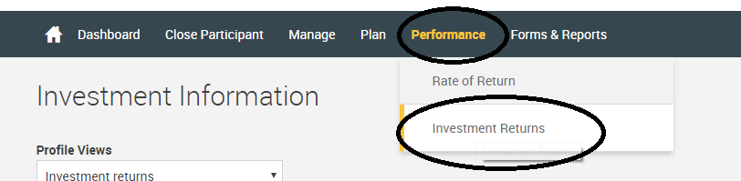

  - You will then see the investment options listed. To the right of each investment name there is a ‘details’ button. Clicking on this ‘details’ button will allow you to select ‘prospectus’. This will bring the prospectus up in an Adobe PDF file for you to view. 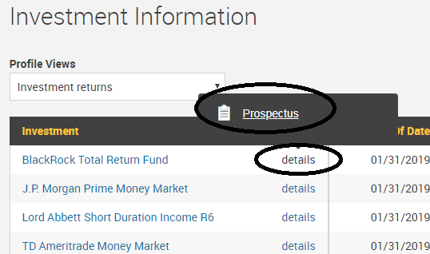

- Going to www.gasawayinvestments.com.
  - In the bar along the top of the screen go to Account Access, then Disclosure Information

  - This will bring up the current prospectus listing for 401(k) plans

  - Click on the fund name and the prospectus will pop up in another window or tab

- Calling our office at (269) 242-4015 / (800) 735-8707 and speaking with a retirement plan representative. We can then mail you a hard copy or e-mail you an electronic version of the prospectus.

- E-mailing our office at rp@gasawayinvestments.com and we can then mail a hard copy or e-mail you an electronic version of the prospectus.

