Investment Option Information

To view detailed information on the investment options available in your plan, you can do one of the following:

- View online via the www.yourbenefitaccount.com/gia401k website. If you do not know your login information, please utilize the “Forgot User ID or Password?” link.

  - Once logged in to your account, go to Performance – Investment Returns.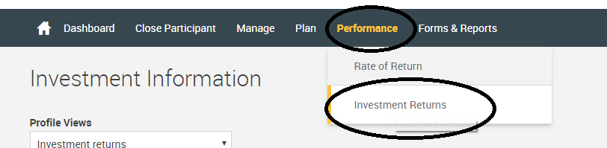

  - You will then see the investment options listed. Click on the investment name that you are inquiring about. This will then open Morningstar in a different tab, where it will go more in depth about each investment.
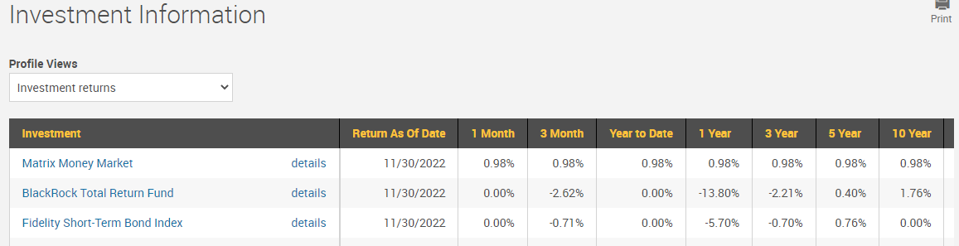

- Call our office at (269) 242-4015 / (800) 735-8707 and speak with a retirement plan representative. We can then mail you a hard copy or e-mail you an electronic version of the investment information.

- E-mail our office at rp@gasawayinvestments.com and we can then mail a hard copy or e-mail you an electronic version of the investment information.

